Lab # 09

System Programming



Teacher | Bibi Areej Khan
Student Name | Muhammad Ahmad Khan
Registration No | 23JZBCS0238

Department of CS&IT
University of Engineering and Technology Peshawar
(Jalozai Campus)

Lab No. 9: Multiple File Copying & Monitoring (Linux)

1. Objectives
- To understand handling of multiple file inputs in Linux
- To differentiate between blocking and non-blocking I/O
- To implement sequential file copying
- To use select() for monitoring multiple file descriptors
- To understand and implement OR synchronization
- To handle multiple files efficiently using I/O multiplexing
- To design scalable solutions for N file inputs

2. Theory
In Linux, a program may need to read data from multiple input sources (files, devices, etc.). A key challenge is that the program does not know which source will provide data first.

Blocking I/O
- Process waits if no data is available
- Causes inefficiency

Solution: I/O Multiplexing
- Allows monitoring multiple inputs simultaneously
- Implemented using select()

OR Synchronization
- The process waits until any one of multiple conditions becomes true
- Example: Data available on any file descriptor

select() System Call
Used to monitor multiple file descriptors.
#include <sys/select.h>

int select(int nfds,
fd_set *readfds,
fd_set *writefds,
fd_set *errorfds,
struct timeval *timeout);

Important Macros
Macro | Purpose
FD_ZERO() | Initialize set
FD_SET() | Add descriptor
FD_CLR() | Remove descriptor
FD_ISSET() | Check readiness

3. Lab Tasks

Task 01 — Sequential File Copy

Code (task1.c)
#include <stdio.h>
#include <fcntl.h>
#include <unistd.h>

void copy_file(const char *src, const char *dest)
{
int in = open(src, O_RDONLY);
int out = open(dest, O_WRONLY | O_CREAT | O_TRUNC, 0644);

char buffer[1024];
int n;

while ((n = read(in, buffer, sizeof(buffer))) > 0)
{
write(out, buffer, n);
}

close(in);
close(out);
}

int main(int argc, char *argv[])
{
if (argc != 5)
{
printf("Usage: %s src1 dest1 src2 dest2\n", argv[0]);
return 1;
}

copy_file(argv[1], argv[2]); // first file
copy_file(argv[3], argv[4]); // second file

printf("Sequential copy completed\n");

return 0;
}

Explanation
- Accepts two source and two destination files from command line
- Uses a helper function to copy file content
- Executes sequentially:
  - First file copy completes
  - Then second file copy starts
- Uses low-level I/O system calls

Output

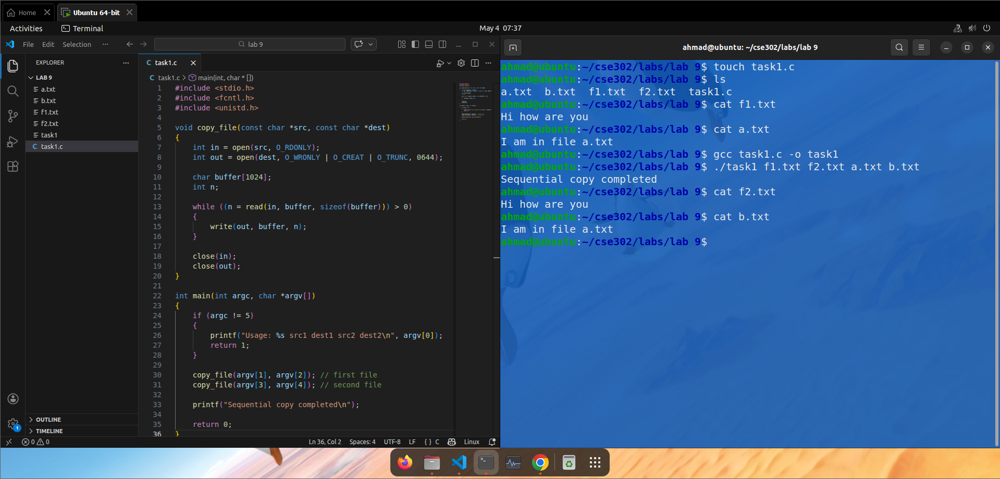

Task 02 — Monitor Two Files Using select()

Code (task2.c)
#include <stdio.h>
#include <fcntl.h>
#include <unistd.h>
#include <sys/select.h>

int main()
{
int fd1 = open("file1.txt", O_RDONLY);
int fd2 = open("file2.txt", O_RDONLY);

fd_set readfds;
char buffer[100];

int done1 = 0, done2 = 0;

while (!done1 || !done2)
{
FD_ZERO(&readfds);

if (!done1) FD_SET(fd1, &readfds);
if (!done2) FD_SET(fd2, &readfds);

int maxfd = (fd1 > fd2 ? fd1 : fd2) + 1;

select(maxfd, &readfds, NULL, NULL, NULL);

if (!done1 && FD_ISSET(fd1, &readfds))
{
int n = read(fd1, buffer, sizeof(buffer));
if (n > 0)
write(1, buffer, n);
else
done1 = 1;
}

if (!done2 && FD_ISSET(fd2, &readfds))
{
int n = read(fd2, buffer, sizeof(buffer));
if (n > 0)
write(1, buffer, n);
else
done2 = 1;
}
}

close(fd1);
close(fd2);

return 0;
}

Explanation
- Opens two files for reading
- Uses select() to monitor both descriptors
- Reads from whichever file is ready first
- Uses flags to track completion
- Demonstrates OR synchronization

Output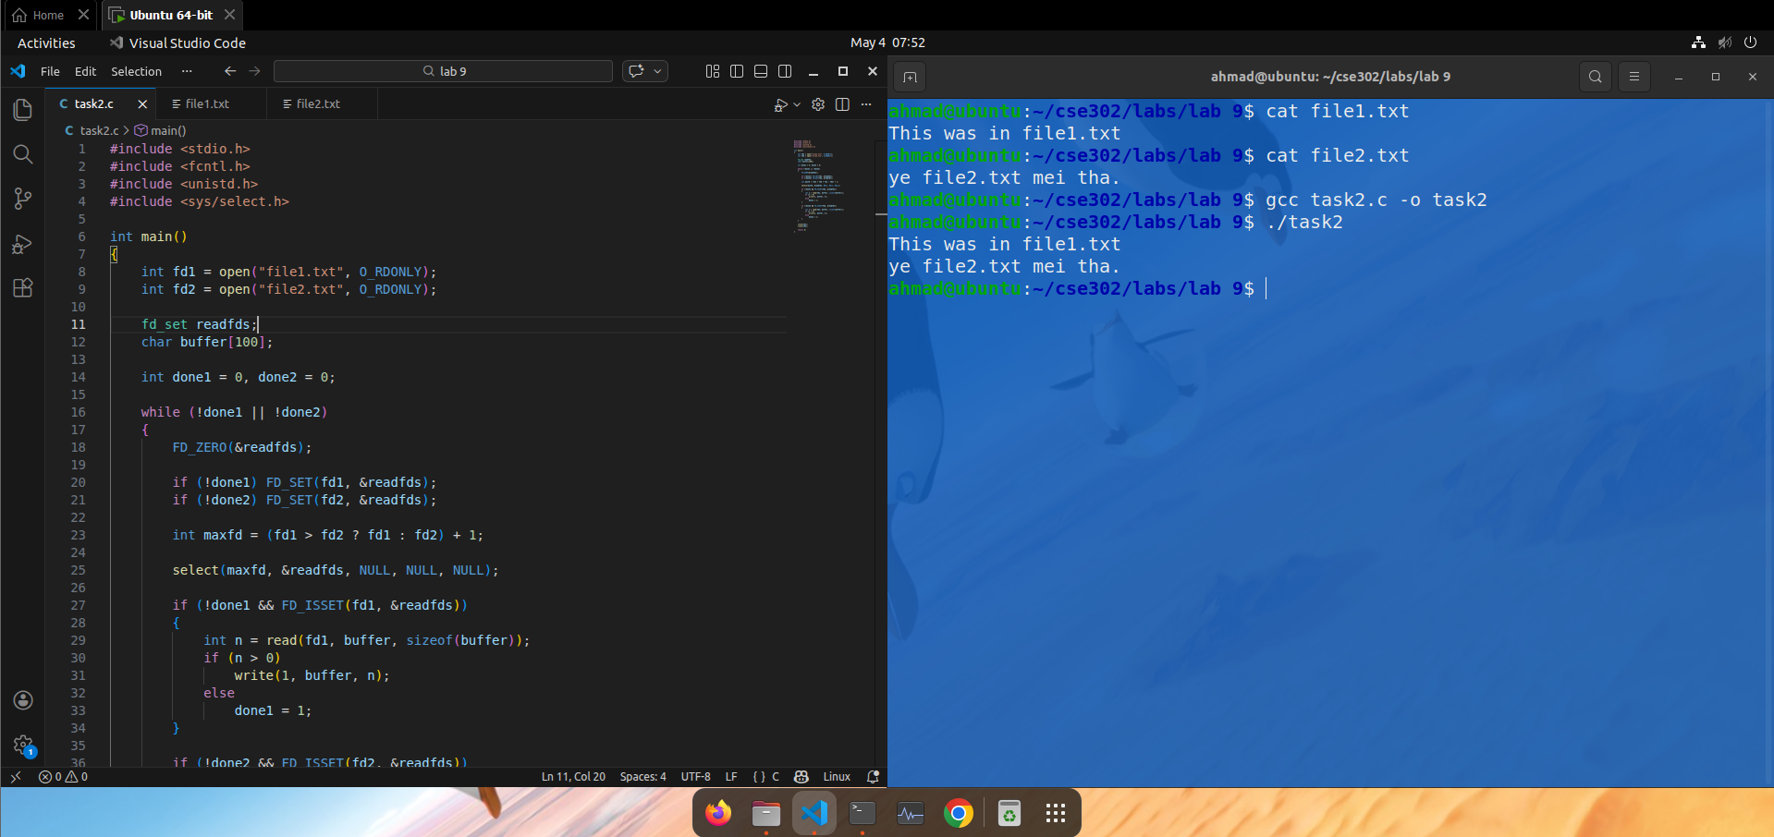

Task 03 — Monitor Multiple Files (N Files) Using select()

Code (task3.c)
#include <stdio.h>
#include <fcntl.h>
#include <unistd.h>
#include <sys/select.h>

int main(int argc, char *argv[])
{
if (argc < 2)
{
printf("Usage: %s file1 file2 ...\n", argv[0]);
return 1;
}

int n = argc - 1;

int fds[n];
int done[n];

char buffer[100];
fd_set readfds;

// initialize
for (int i = 0; i < n; i++)
{
fds[i] = open(argv[i + 1], O_RDONLY);
done[i] = 0;
}

int remaining = n;

while (remaining > 0)
{
FD_ZERO(&readfds);
int maxfd = 0;

for (int i = 0; i < n; i++)
{
if (!done[i])
{
FD_SET(fds[i], &readfds);
if (fds[i] > maxfd)
maxfd = fds[i];
}
}

select(maxfd + 1, &readfds, NULL, NULL, NULL);

for (int i = 0; i < n; i++)
{
if (!done[i] && FD_ISSET(fds[i], &readfds))
{
int bytes = read(fds[i], buffer, sizeof(buffer));

if (bytes > 0)
{
write(1, buffer, bytes);
}
else
{
done[i] = 1;
remaining--;
close(fds[i]);
}
}
}
}

return 0;
}

Explanation
- Accepts multiple file names from command line
- Opens all files and stores descriptors
- Uses select() to monitor all inputs
- Processes whichever file is ready
- Tracks completion using an array
- Demonstrates scalability

Output

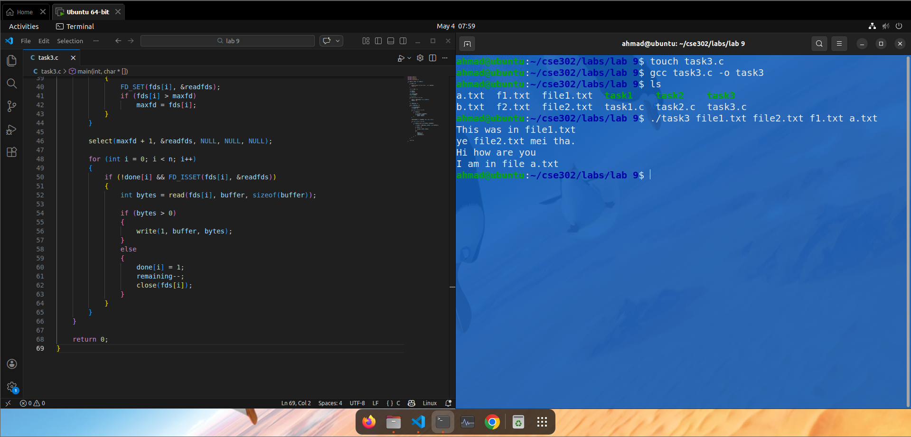4. Conclusion
- Sequential file copying is simple but not efficient for multiple sources
- Blocking I/O can slow down programs
- select() enables efficient monitoring of multiple file descriptors
- OR synchronization improves responsiveness
- The system becomes scalable when handling multiple files dynamically

